How to Add Basketball Tickets to an Existing Staff Conference Registration

If You Have Not Yet Registered:
Please use the registration link and complete your registration as normal.
At the bottom of the registration page, you will see the “Event Registration Fees” section, which includes the OKC Thunder Game option. Leave the checkbox selected, add the registration to your cart, and complete payment as usual.
Important: If you are registering a guest or spouse for a game ticket only, staff assistance is required. Please contact Sophie DeHoff for help.

Step 1: Login to your MyNLC account. In the content box on the right side of the screen, select “My Events.”
Note: Follow the highlighted yellow in all images.
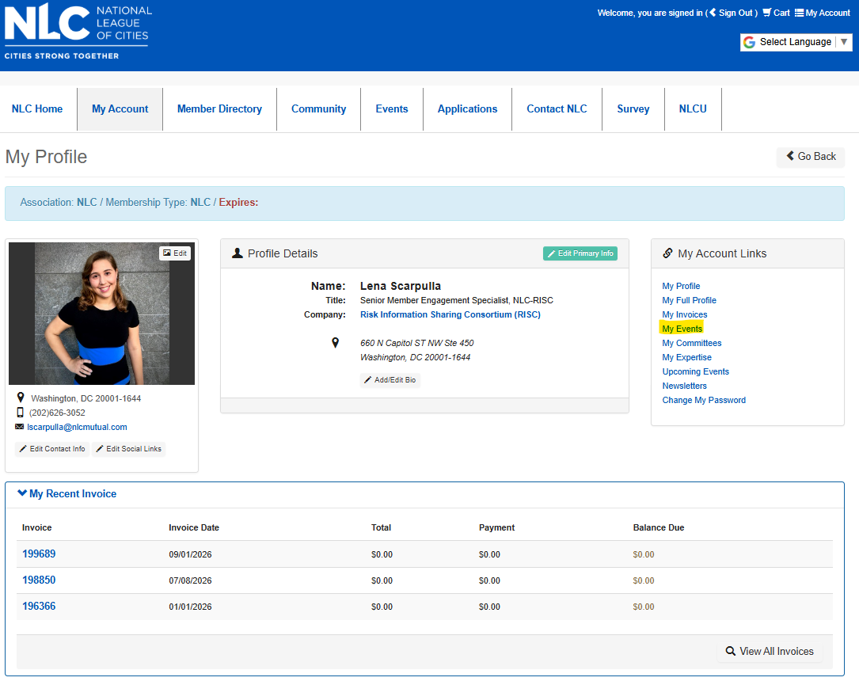
Step 2: Under My Events, select “2026 NLC-RISC Staff Conference.”
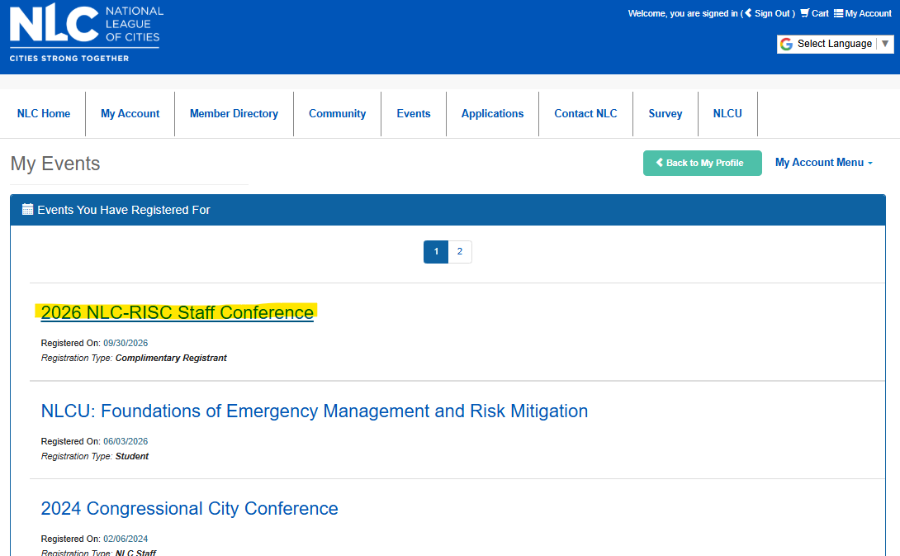

Step 3: Click “Add Track/Sessions” in the bottom-right corner.
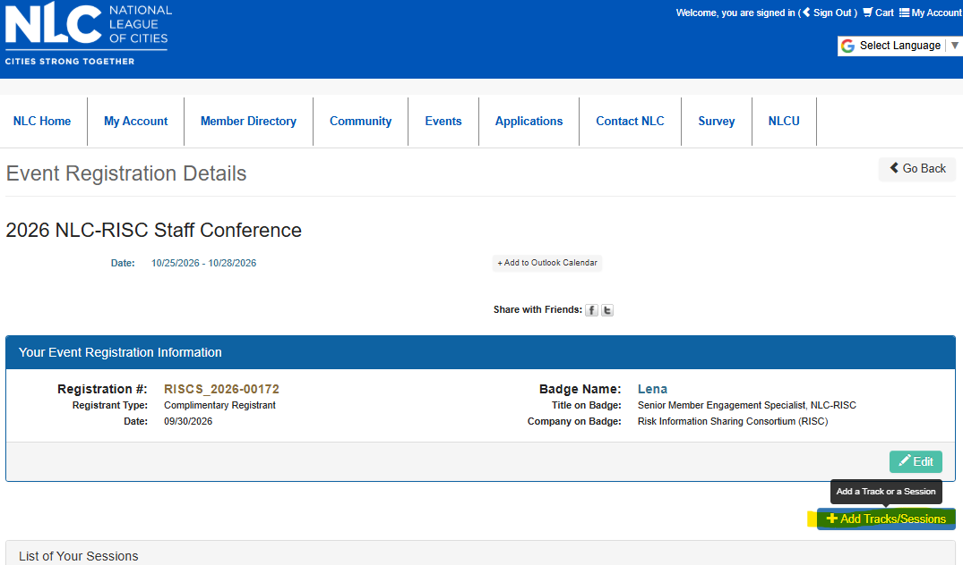

Step 4: You will be taken to the shopping cart. Select the “OKC Thunder Game” product and click “Save/Add to Cart.” Complete the payment process as normal.
Please note: Basketball tickets will be distributed at a later date. Additional information regarding ticket distribution will be shared when available.
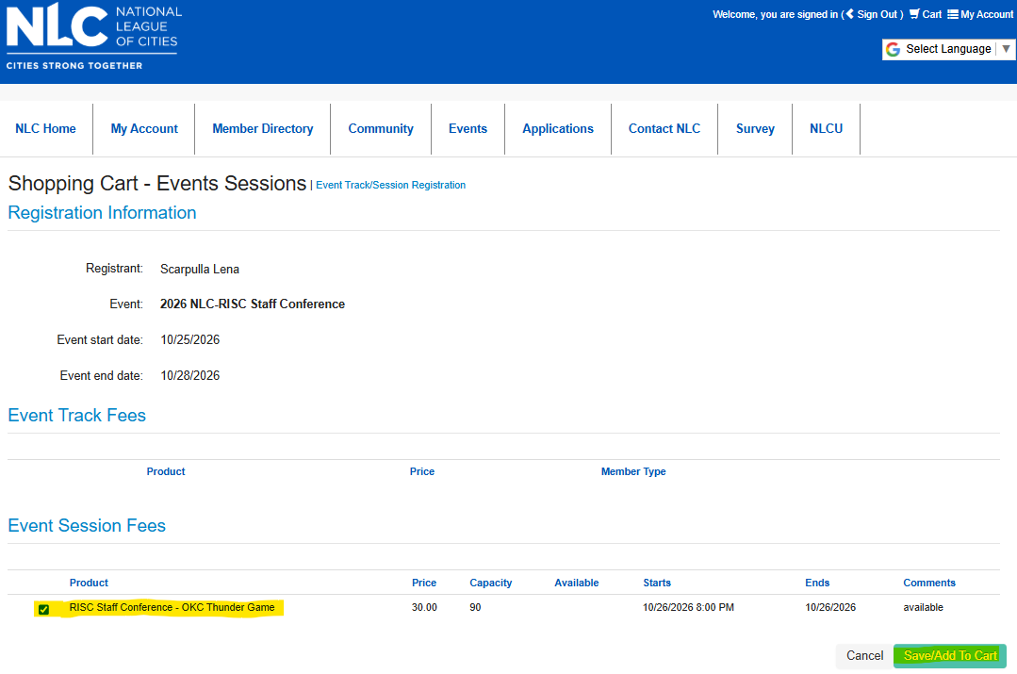
Need Help?
If you experience any issues adding basketball tickets to your registration, please contact Sophie DeHoff for assistance.

