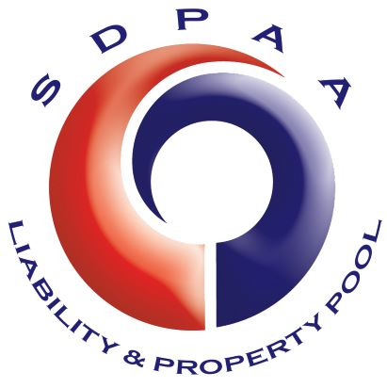 YOUR FUTURE IN PUBLIC SERVICE

The South Dakota Public Assurance Alliance (SDPAA)
Member Services Representative

THE SDPAA & THE POSITION

The SDPAA is a public entity pool serving 436 local governments in South Dakota by providing broad coverages for property and liability, including auto and cyber liability. The SDPAA is Member-owned and Member-driven. Since 1987 the SDPAA has been unified in its commitment to assist local government Members with tackling their unique risk management and coverage needs as part of their public service mission. The SDPAA is financially secure and has achieved national recognition for its sound financial and governance practices. The SDPAA employs innovative problem solvers who help local communities in South Dakota become safer, stronger, and healthier.

The SDPAA Member Services Representative is a point of contact for SDPAA Members by providing outstanding customer service by verbal or written communications and by conducting in-person visits and presentations to SDPAA Members across South Dakota. The Representative assists with analyzing the marketing needs of and opportunities for SDPAA programs and services and then collaborates with the SDPAA team to develop new marketing/communication strategies, initiatives, and services for SDPAA Members.

The position is expected to be filled within a salary range of $65,000 - $100,000 annually depending on the qualifications and experience of the successful candidate. The benefits package for the position includes group health insurance and retirement package through the South Dakota Retirement System pension benefits. The position will work remotely with a desired duty station in central or west river South Dakota. The SDPAA will consider negotiation of relocation expenses if appropriate.

PROFESSIONAL EXPERIENCE AND QUALIFICATIONS

The key criterion for the position is a demonstrated understanding and appreciation of the current issues facing local governments. Other key criteria include excellent communication skills along with the ability to work independently and as part of a team. Experience in risk management and insurance delivery to the governmental community and within the pooling environment is also highly desirable.

Qualifications for this position are normally acquired through at least ten years of experience with a concentration on risk management and/or insurance-related issues for one or more public entities. A desirable, but not required, academic background and designations may include an undergraduate degree in business or public administration, finance, accounting, risk management, insurance or a related field. Credential designations obtained through one of the various insurance industry organizations are also desirable, but not required. The successful candidate will have the experience, education and credentials that, in combination, demonstrate the abilities to successfully perform this position in the sole determination of the SDPAA.

CONTACT

For a complete description of the position and for the Employment Application please go to www.sdpaaonline.org

Please email any inquiries to sdpaa@sdmunicipalleague.org or contact Dave Pfeifle, Executive Director, at 605-224-8654 (option two) or 800-658-3633 (option two).

The completed Employment Application and all supporting documentation must be submitted by April 30, 2022 to the following:

By email: sdpaa@sdmunicipalleague.org or
By mail: SDPAA, Attention Dave Pfeifle, 208 Island Drive, Ft. Pierre, SD 57532
Interviews are expected to be conducted the week of May 9, 2022 at the SDPAA office in Ft. Pierre. If an ADA accommodation is needed, please contact, 72 hours prior to closing date, Dave Pfeifle, Executive Director, at 605-224-8654 (option two) or 800-658-3633 (option two), or sdpaa@sdmunicipalleague.org.

